**Re Assure API Internal Testing**

Contents

Re Assure API Internal Testing-Estimation Approval API 1

Re Assure API Internal Testing- Escalated Cases API 2

Re Assure API Internal Testing-Claim Cancellation 2

Re Assure API Internal Testing-Estimation Approval API  
Applicable for Acko only)***

1. Please change “Entity” to “Claim Approval” in the confirmation message of successful claim approval. Fixed

{

    "status": "Success",

   "message": "Entity has been updated successfully.",

    "data": null

}

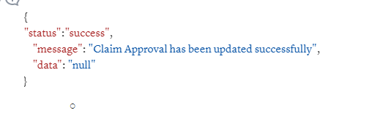

2. Claim status should not get update in case of CPP but this is happening. Fixed

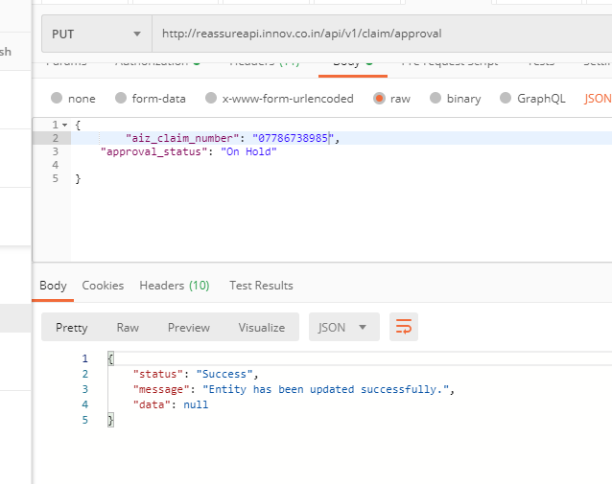

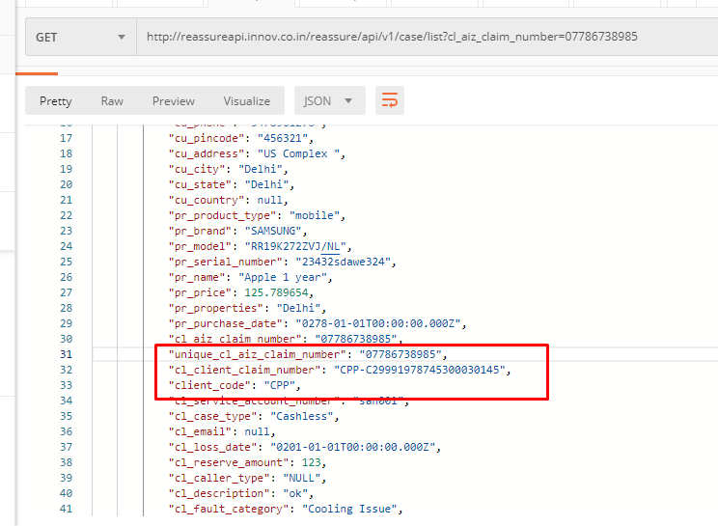

# Re Assure API Internal Testing- Escalated Cases API

1. Please change “Entity” to “Escalation Status” in the confirmation message of successful escalation. Fixed  
     
   {

"status": "Success",

"message": "Entity has been updated successfully.",

"data": null

}

Re Assure API Internal Testing-Claim Cancellation   
Applicable for Acko only)***

1. User is able to cancel the claim without entering “Cancellation Reason” which is a mandatory field. Fixed  
     
     
   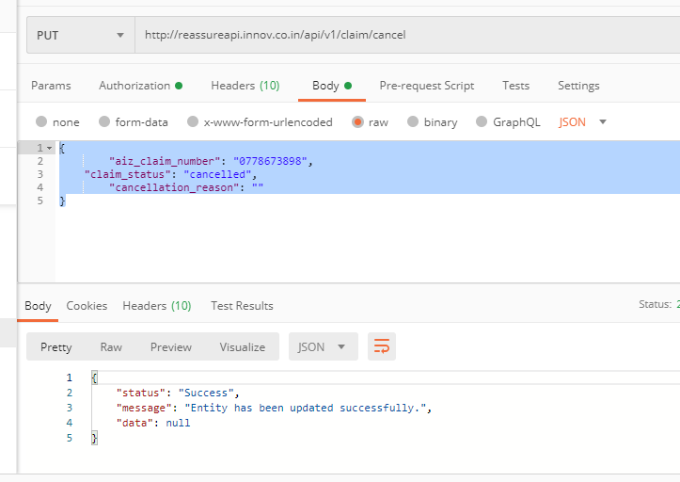  
     
   2. Please change “Entity” to “Escalation Status” in the confirmation message of successful escalation. Fixed  
     
   {

"status": "Success",

"message": "Entity has been updated successfully.",

"data": null

}

3. Claim status should not get update in case of CPP but this is happening. Fixed

